**ASSIGNMENT 1**

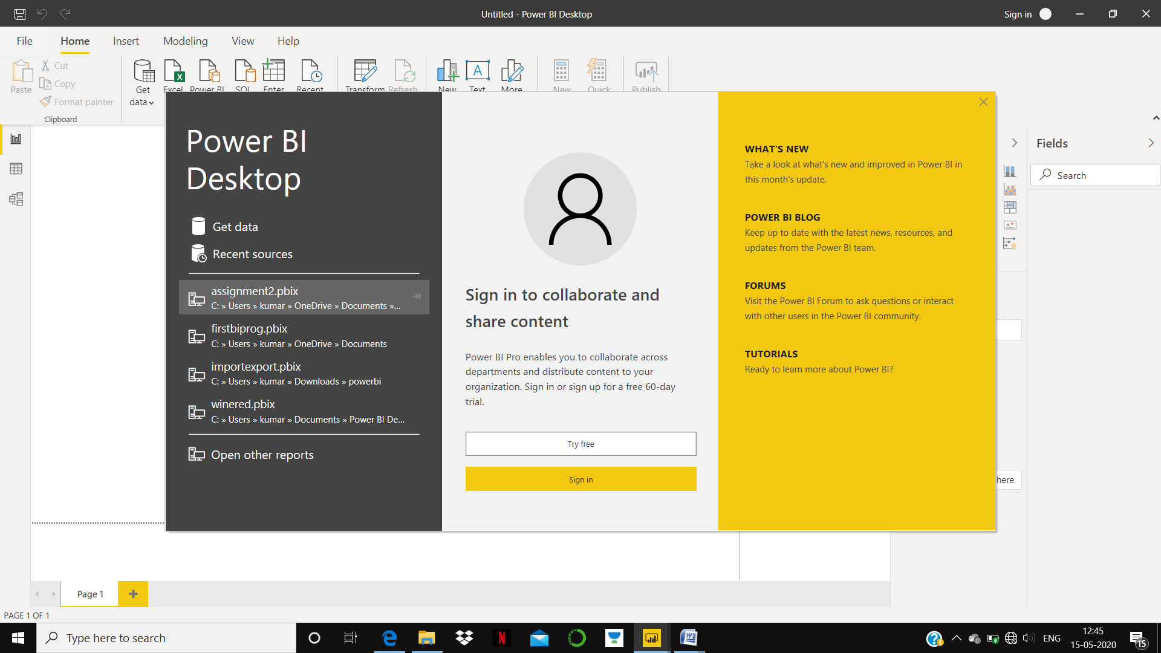

REPORT VIEW

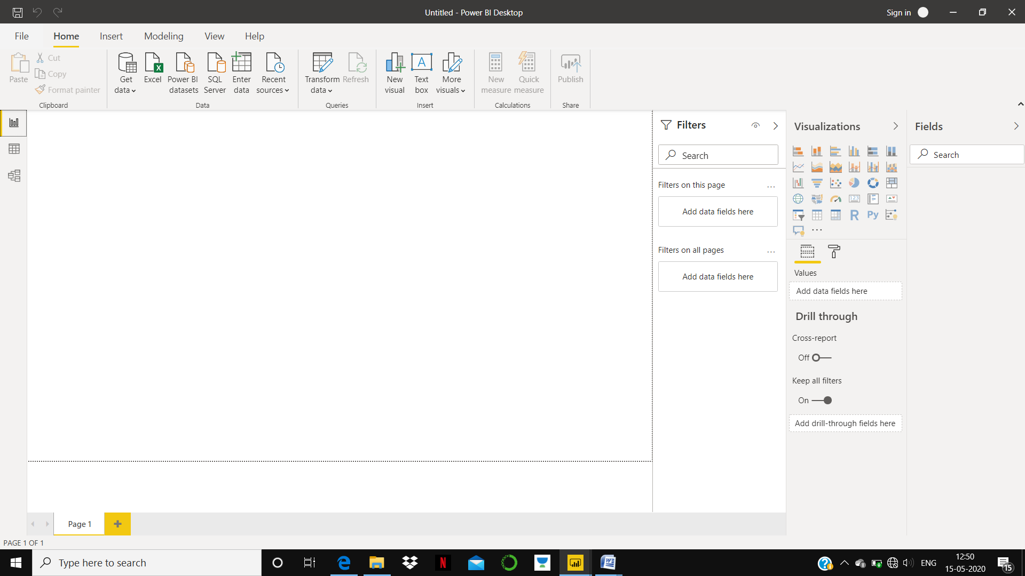

DATA VIEW

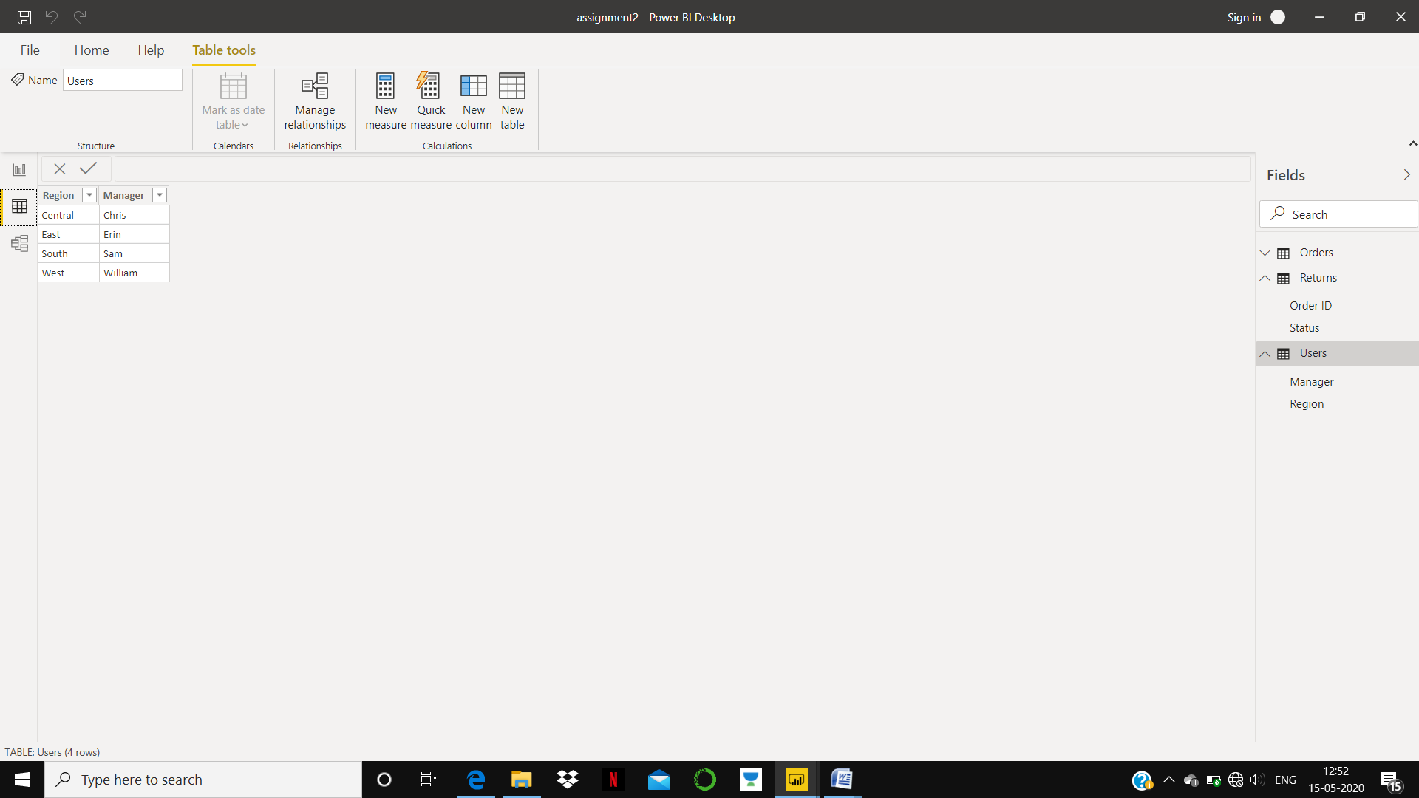

MODEL VIEW:

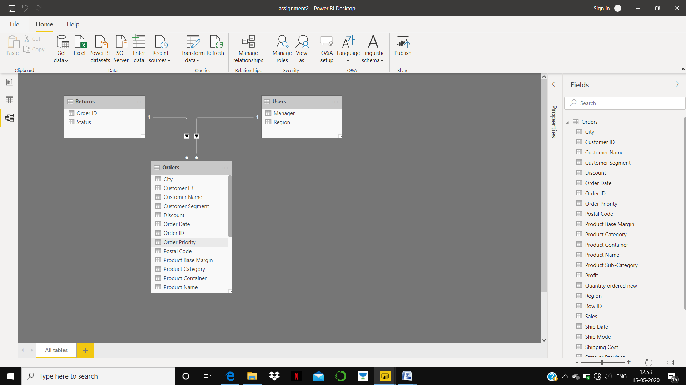

POWER QUERY EDITOR:

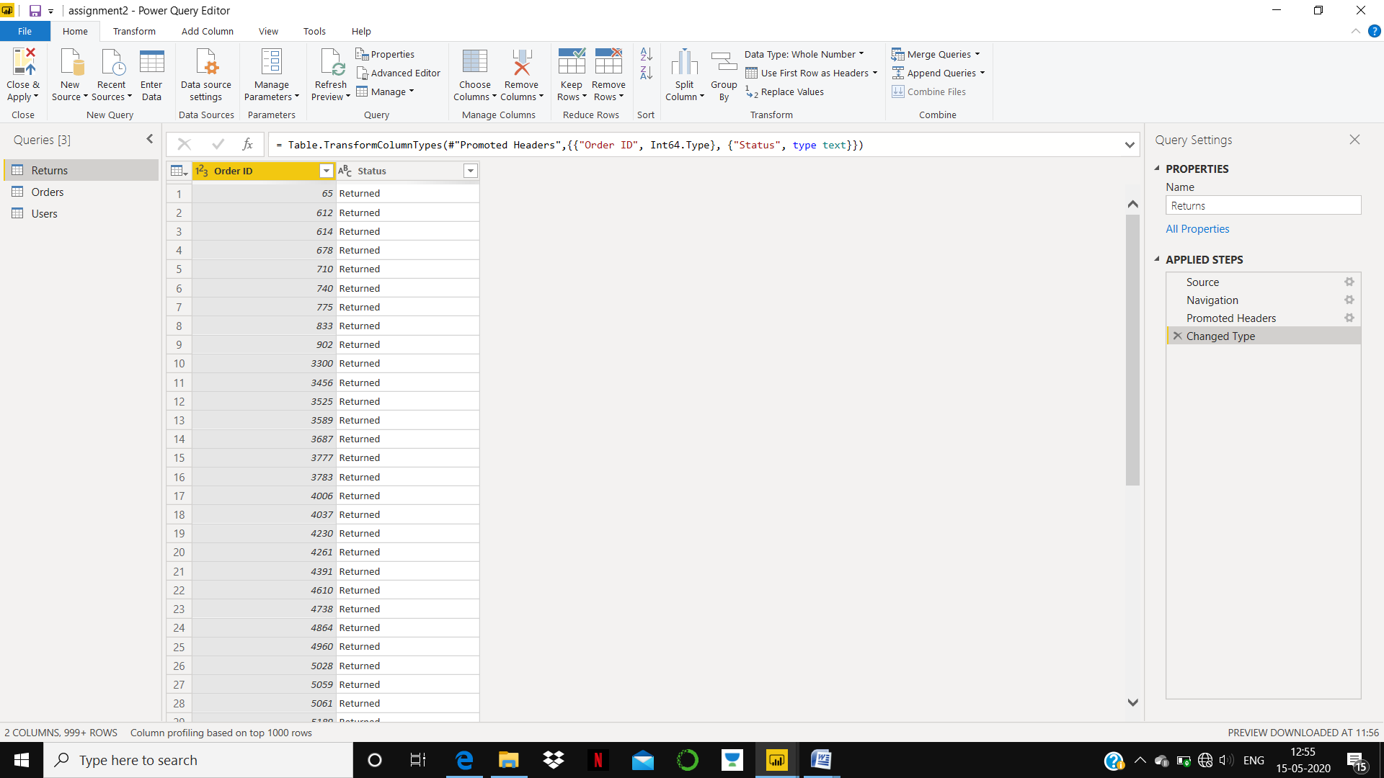

ADVANCE EDITOR:

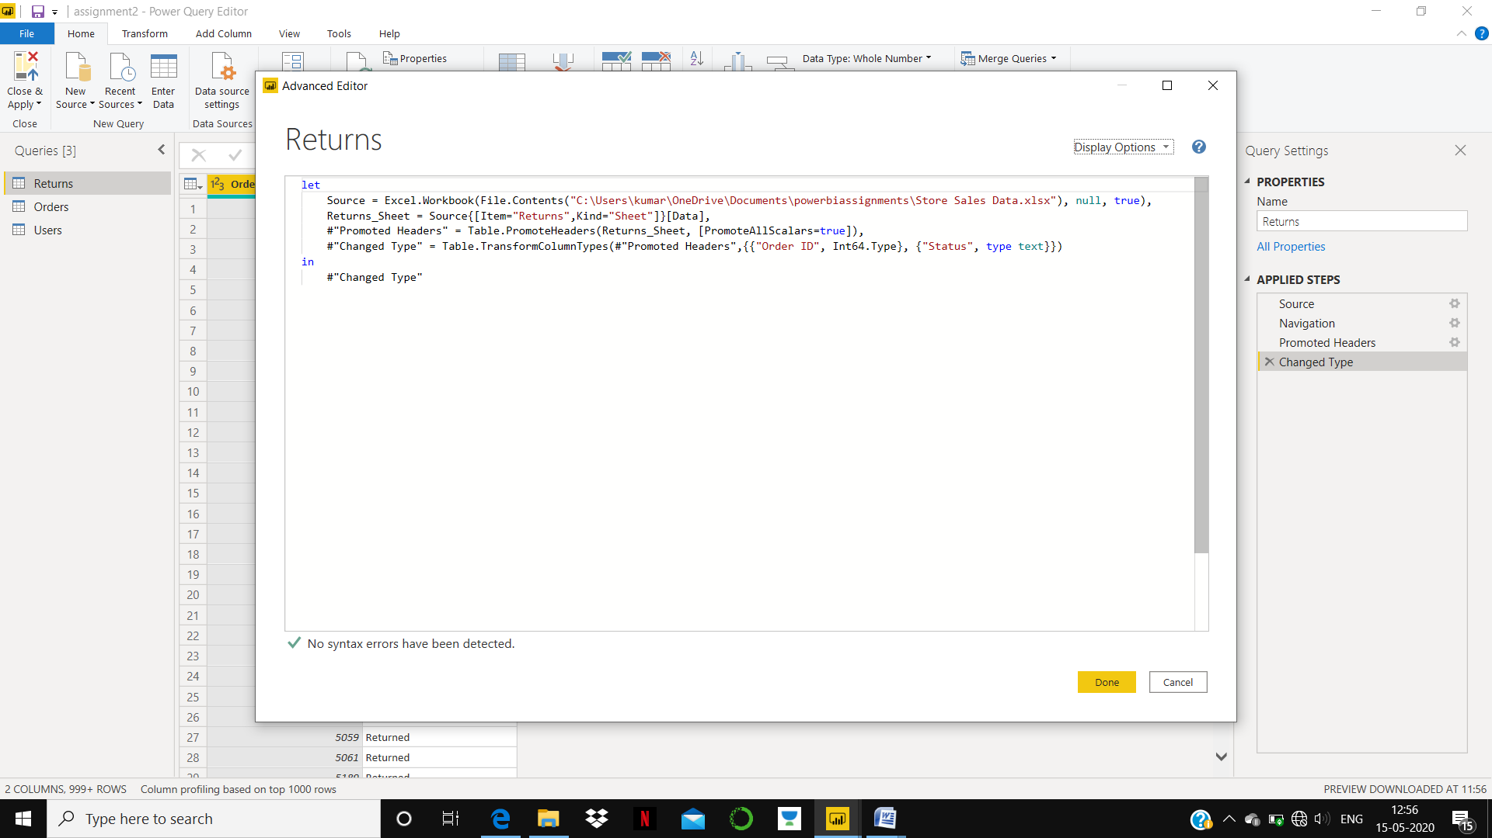

**POWER BI DESKTOP**: CAN BE USED FOR CREATING A DASHBOARD WITH ONLINE STREAMING DATA.IT REQUIRES CREDIT CARD DETAILS WITH FREE 30 DAY TRIAL AND AFTER THAT **8.9$** PER MONTH.

